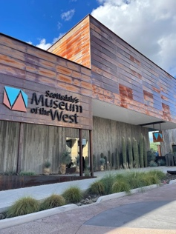
Join us for a tour of the
Western Spirit Museum
A Smithsonian Affiliate
3830 N. Marshall Way, Scottsdale

Wednesday, March 4th, 11:00 AM

Admission: $12.00 with MCC Student ID Card
(Regular Senior admission is $25.00)

GOOGLE MAP LINK

We will meet in the lobby to join a docent-led, 45-minute tour that begins at 11:20 AM.
Current exhibits include: “Still in the Saddle: A New history of the Hollywood Western”.
Museum admission includes option to hear Dr. Andrew P. Nelson, Chief Curator,
give a talk on the “Westerns of Clint Eastwood” at 2:00 PM.

Go to: Now on View for information on other current exhibits.

RSVP to Joanne Handlong by Monday, March 2nd
Email: justjo34@gmail.com Phone: 480.296.8512

Free parking in garage under museum.
Carpooling from MCC Dobson Campus will be available, leaving at 10:15 AM.

Brought to you by NFLL Social Committee. For information on more upcoming activities go to: https://newfrontiers.mesacc.edu/social.html
New Frontiers for Lifelong Learning – MCC, Community Partnerships Office
7110 E. McKellips - DW 136-B Mesa, AZ 85207 United States

